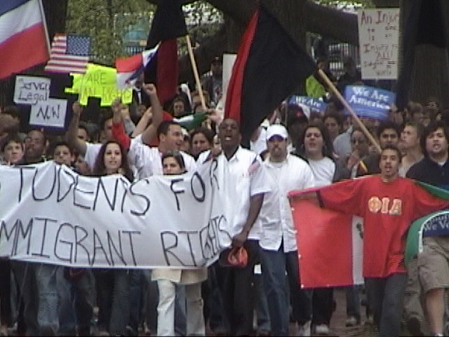
May 17th
Rally & March for Immigrant Rights!
Boston Common – 4pm

Called by the April 10th Coalition and supported by the Boston May Day Coalition – www.bostonmayday.org

- Permanent residency for all undocumented immigrant workers and their families immediately

- No to HR4437!

- No to the criminalization of immigration laws.

- No to the militarization of the borders

- No to another wall of shame

- For humane immigration policies

- Recognize undocumented immigrants contribution to the economy and society

- No to guest worker / “bracero” programs

- Let’s build worker to worker solidarity

- Stop the abuse, exploitation and victimization of undocumented immigrants.

- No human being should ever be illegal.

