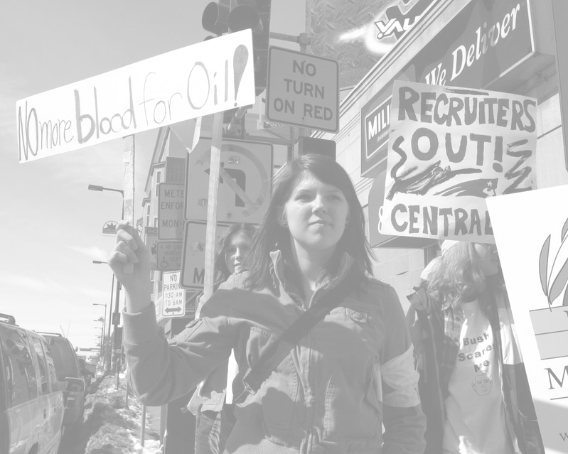
Help organize the
STUDENT WALKOUT
to protest the War in Iraq
PLANNING MEETING/TEACH-IN
SATURDAY, SEPTEMBER 1, 3PM
encuentro 5 – Chinatown
33 Harrison Ave, 5th flr, Boston, MA 02111
www.StudentWalkout.info

High school students face military recruiters in their schools every day. College students hear the ROTC advertised as a “cost-free” alternative to college debt. Plan the fightback!

THE TIME FOR ACTION IS NOW!

